**COIT20259 (HT1, 2018) ENTERPRISE COMPUTING ARCHITECTURE**

**Assessment 2 Report**

Lecturer and Tutor: Naveed Ali

Prepared by:

Student Name: Prajalkumar Natvarlal Ramjiyani

Student Number: 12045947

Contents

1. Architecture of Application 3

2. Description of tier component interaction and page navigation 4

2.1 Workflow 5

2.2 A Demonstration of the Functionality of the e-Business System 7

3. End User Manual and test instruction 16

3.1 Application compiling and deployment steps 16

3.2 Test Cases 18

4. Coverage of the Application scenario 21

5. Assumptions 22

# Architecture of Application

Below diagram shows the architecture of E-Business online system

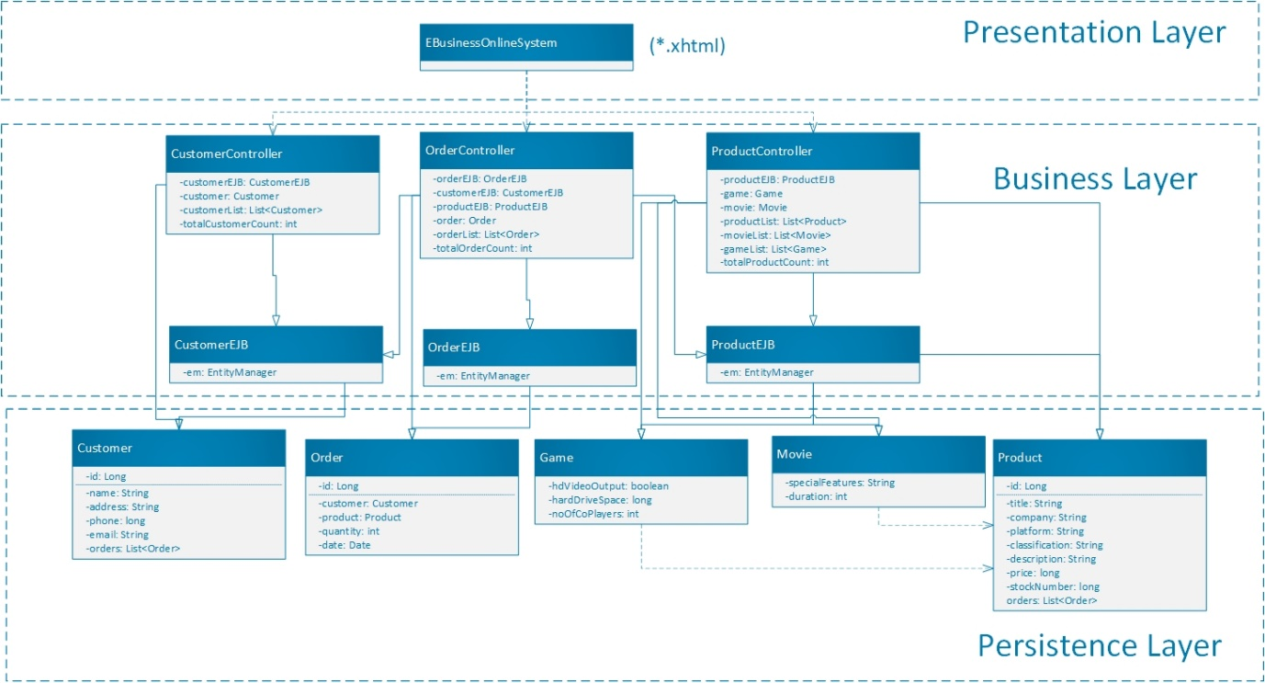

# Description of tier component interaction and page navigation

Application is designed with consideration of three tier application where in Presentation layer will be developed using Java Server Faces (JSF) which is responsible to provide UI to customers. Business layer will be defined in controller classes with directly interact with JSF to provide necessary data from database layer. In persistence layer we decided to use Java Persistence API (JPA) to make system more configurable. The main reason behind choosing three tier architectures: it provides more flexibility to the organization in teams of database selection if number of users/data increase rapidly. Moreover, for developer its easy to debug or find any error in program. It is also loosely coupled where each layer is separated so if later customer wants to change UI that can be easily changed without putting more efforts, also they need not to warry about backend code changes. Let’s talk about bit more of development perspectives:

Presentation Layer(View) can have following files:

1. index.xhtml
2. customerDetails.xhtml
3. listCustomers.xhtml
4. listGames.xhtml
5. listMovies.xhtml
6. listOrders.xhtml
7. newCustomer.xhtml
8. newGame.xhtml
9. newMovie.xhtml
10. newOrder.xhtml
11. productDetails.xhtml
12. removeOrder.xhtml
13. searchCustomer.xhtml
14. searchGame.xhtml
15. searchMovie.xhtml
16. searchPrder.xhtml
17. orderErrorMessage.xhtml

Business layer (Controller & EJBs) can have following files:

1. CustomerController.java
2. OrderController.java
3. ProductController.java
4. CustomerEJB.java
5. ProductEJB.java
6. OrderEJB.java

Persistence layer (Model) can have following files:

1. Customer.java
2. Movie.java
3. Game.java
4. Product.java
5. Order.java

## Workflow

Below diagram shows the page navigation

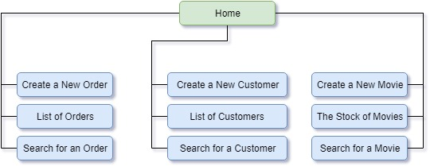

As we can see in above diagram there are mainly 10 pages available which user can visit to take advantage of E-Business System.

To understand more about system workflow, we can consider following example where customer can create an order:

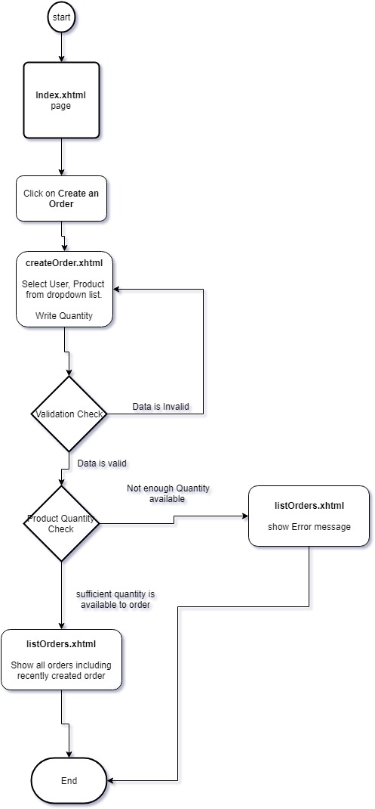

## A Demonstration of the Functionality of the e-Business System

1. The main JSF page of the e-business system

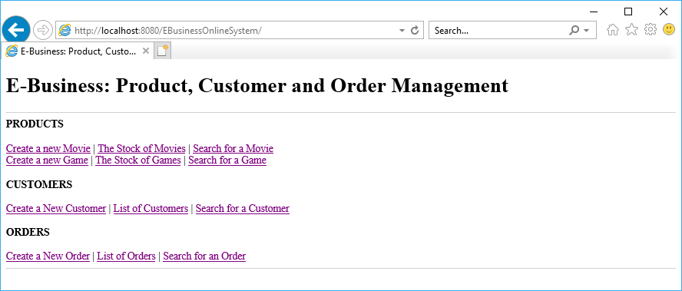

1. Create a movie or a game

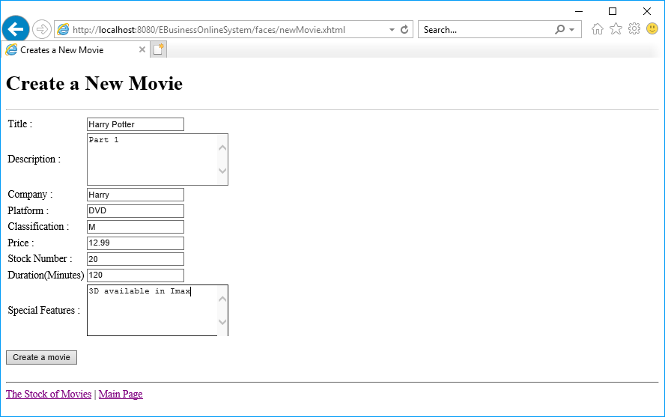

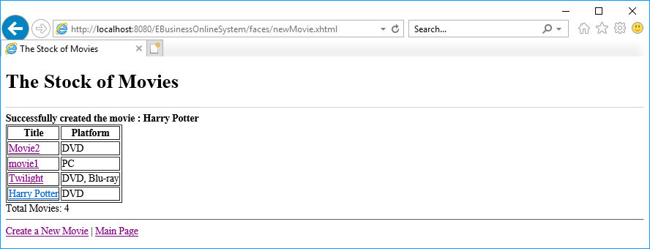

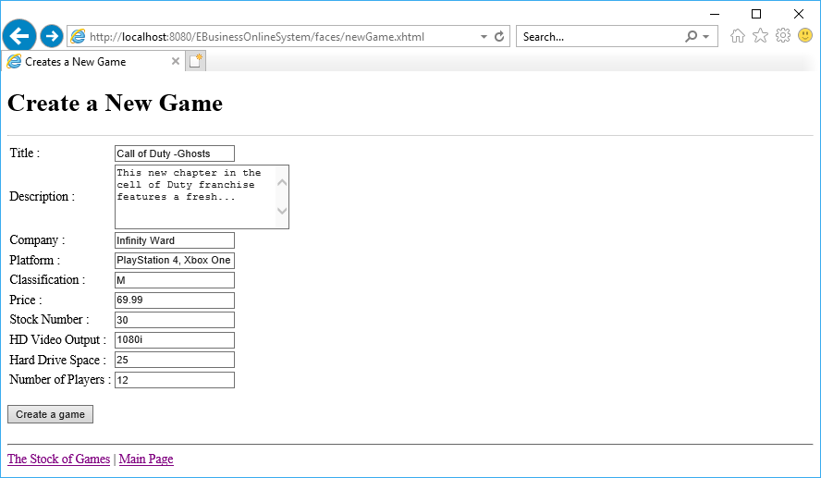

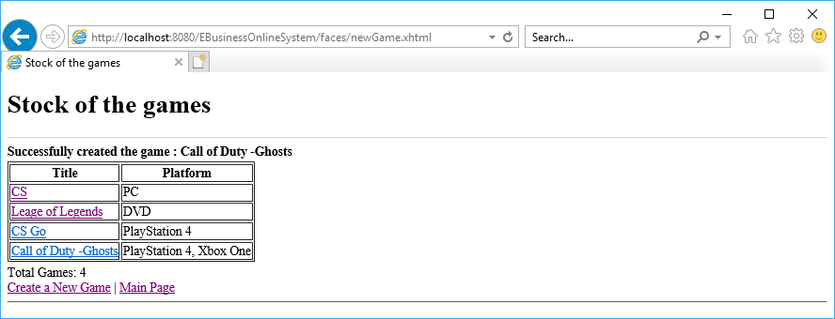

1. Create a customer

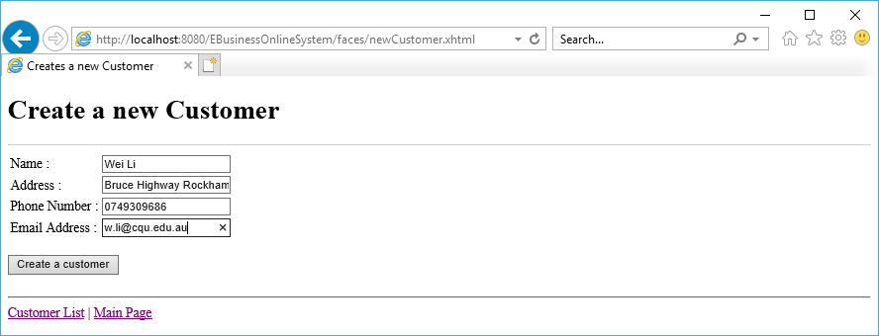

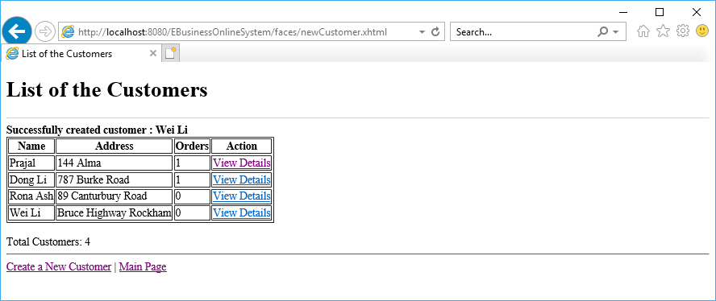

1. Check the movie or game stocks

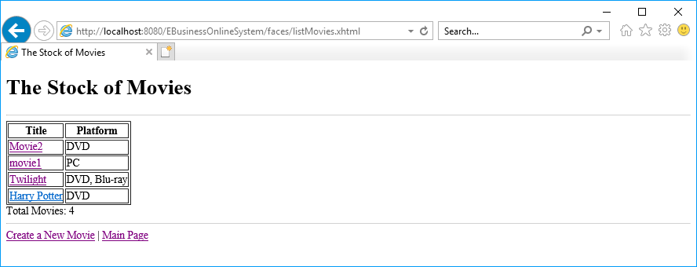

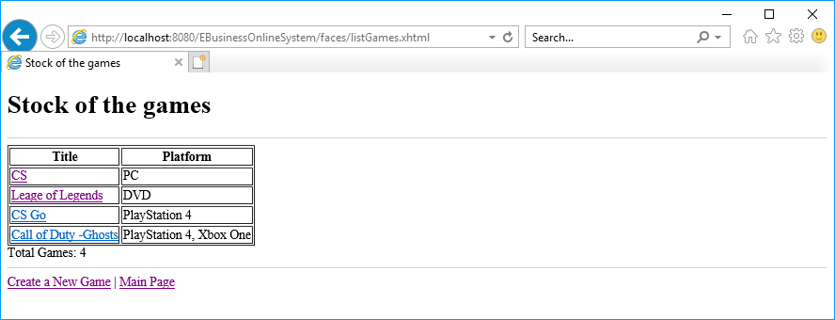

1. List customers

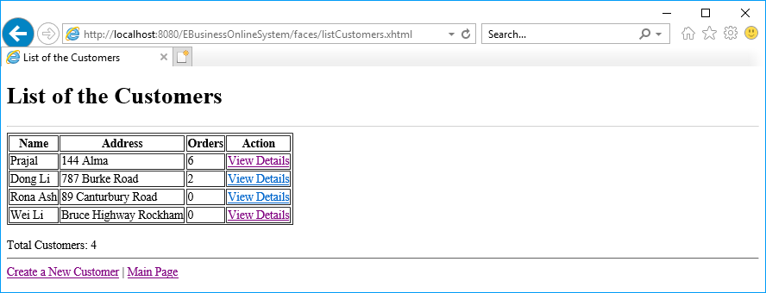

1. Create an order

Note: before creating an order for a movie: Harry Potter, the number of the movie in stock is 20.

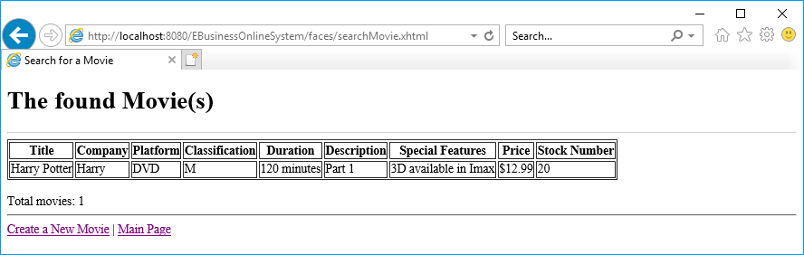

Creating an order for a movie

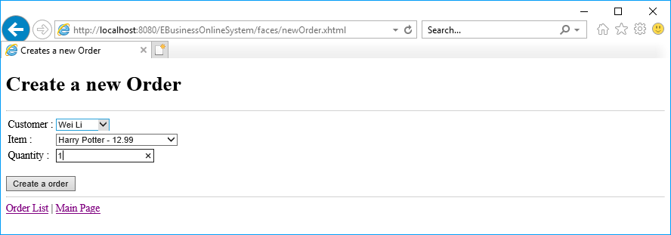

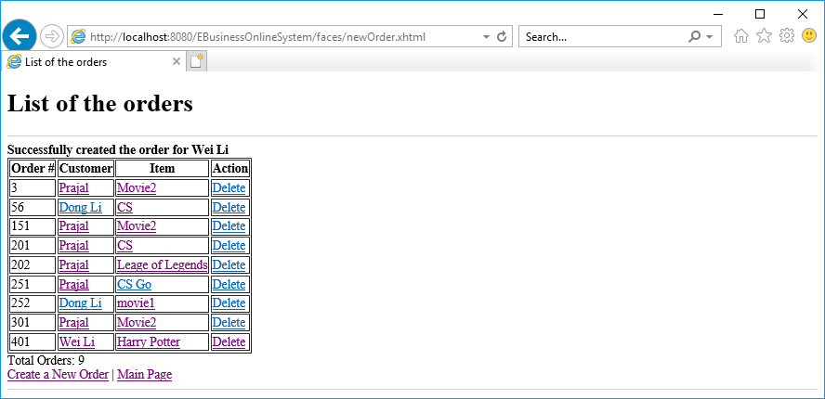

Note: after creating the order, the number of the movie: Harry Potter in stock is 19.

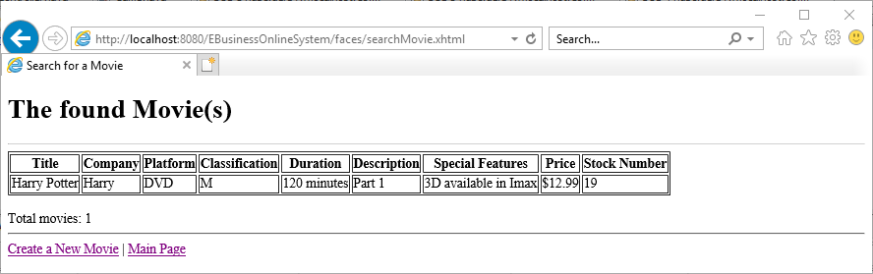

1. List of orders

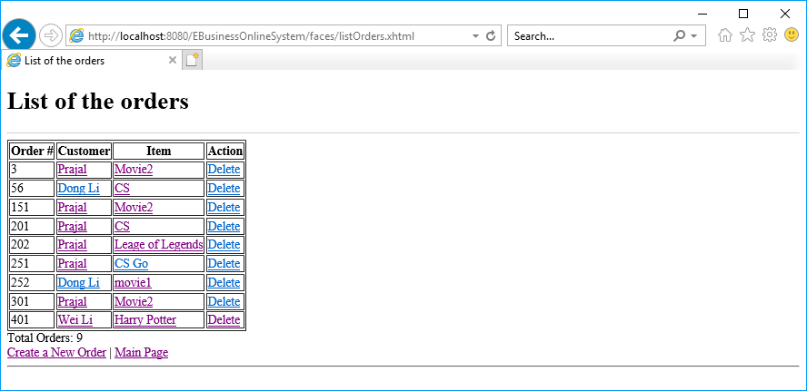

1. Search for a movie or game

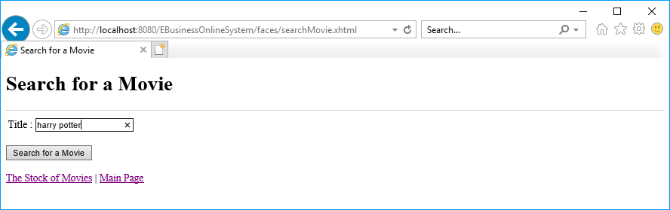

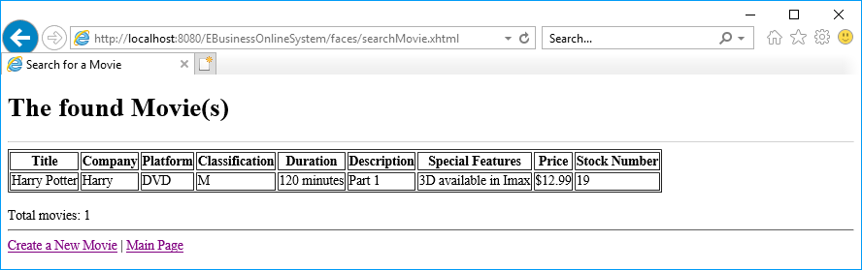

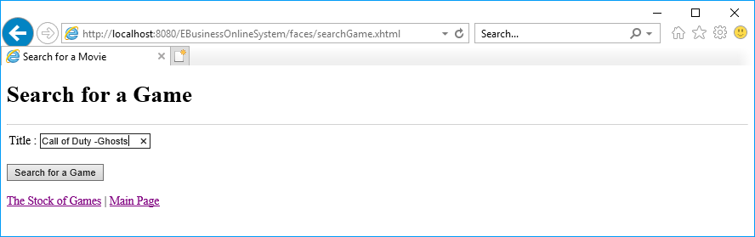

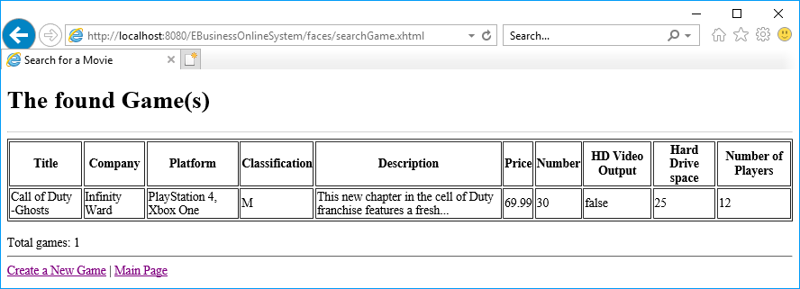

1. Search for a customer

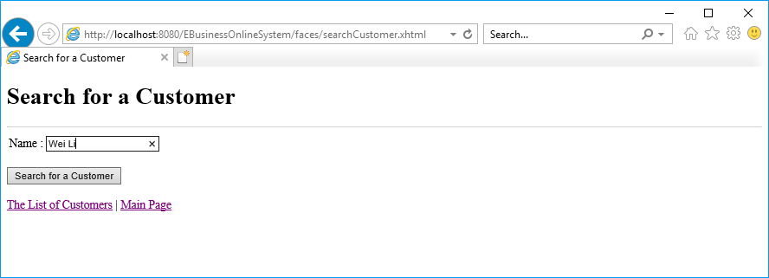

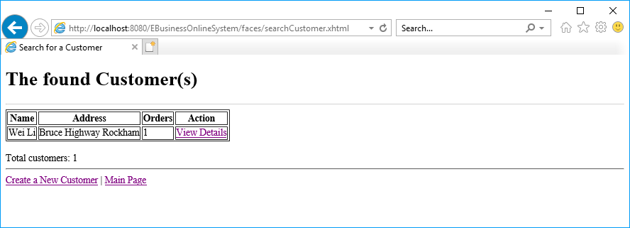

1. Search for an order

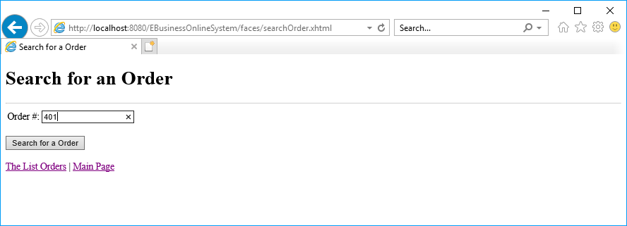

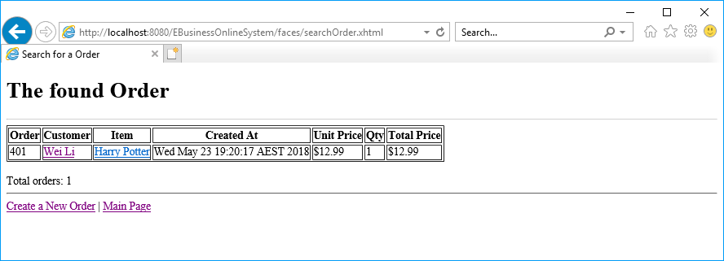

1. Delete an order

Note: before deleting the order of movie: Harry Potter, the number of the movie in stock is 19.

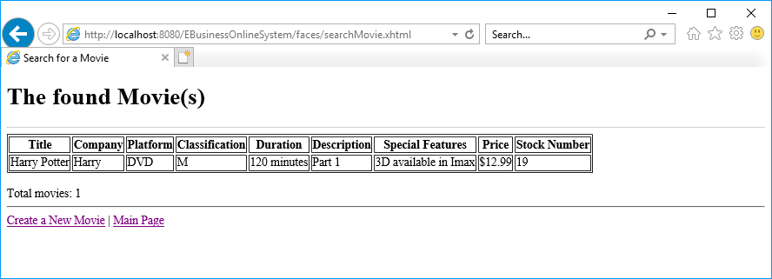

Clicking the Delete link to delete the order of movie: Harry Potter (Order # 401)

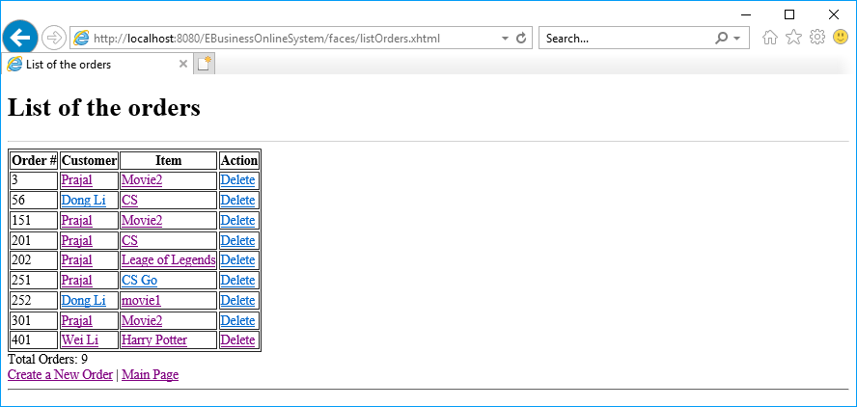

The order has been deleted.

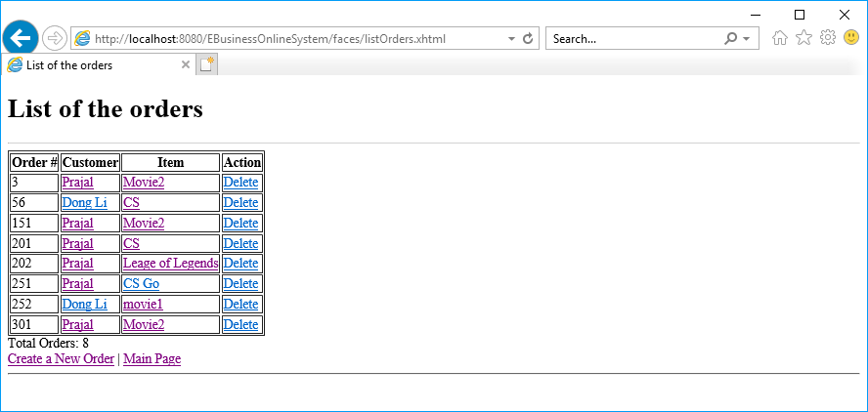

Note: after deleting the order, the stock number of movie: Harry Potter is 20.

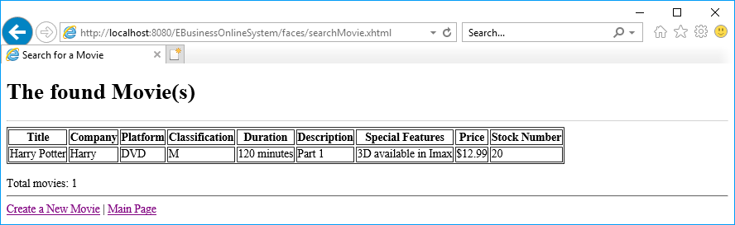

1. Check a customer’s details including his/her orders

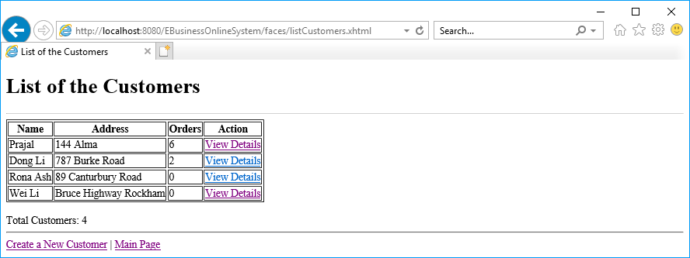

Clicking the View Details link

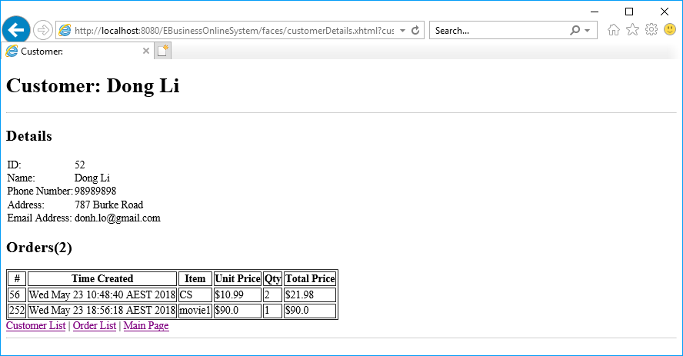

# End User Manual and test instruction

## Application compiling and deployment steps

Prior to deployment there are some prerequisites that must satisfied to deploy and run this application successfully:

1. Derby Database (W5DS database should be created)
2. Glassfish server with configured data source and connection pool with “jdbc/W5DS” name.
3. NetBeans IDE 8.*

**Step1: Open project in NetBeans**

Click on File menu > select Open Project > select “EBusinessOnlineSystem” project from appropriate location > Click on Open Project button.

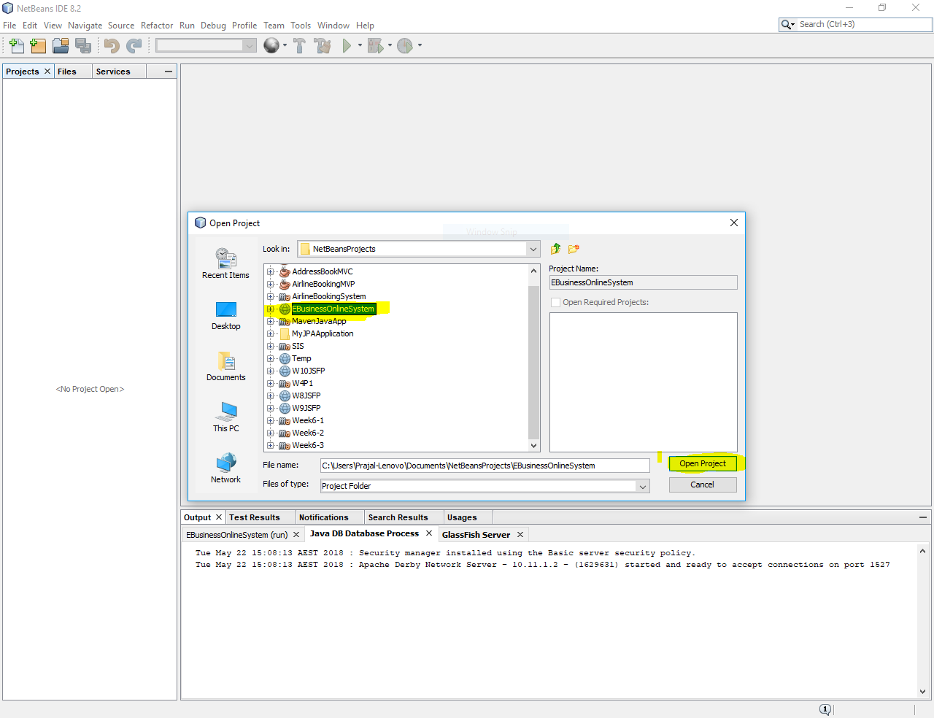

**Step 2: Build Project**

Right click on “EBusinessOnlineSystem” project and click on build.

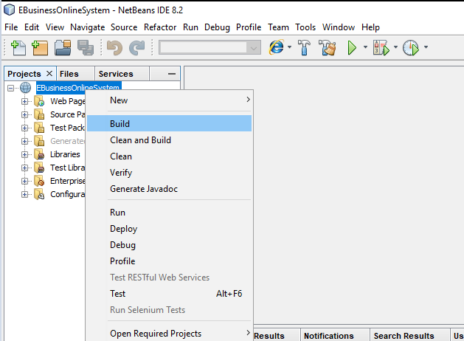

Once its successfully build you can see BUILD SUCCESSFUL message as shown in below screen

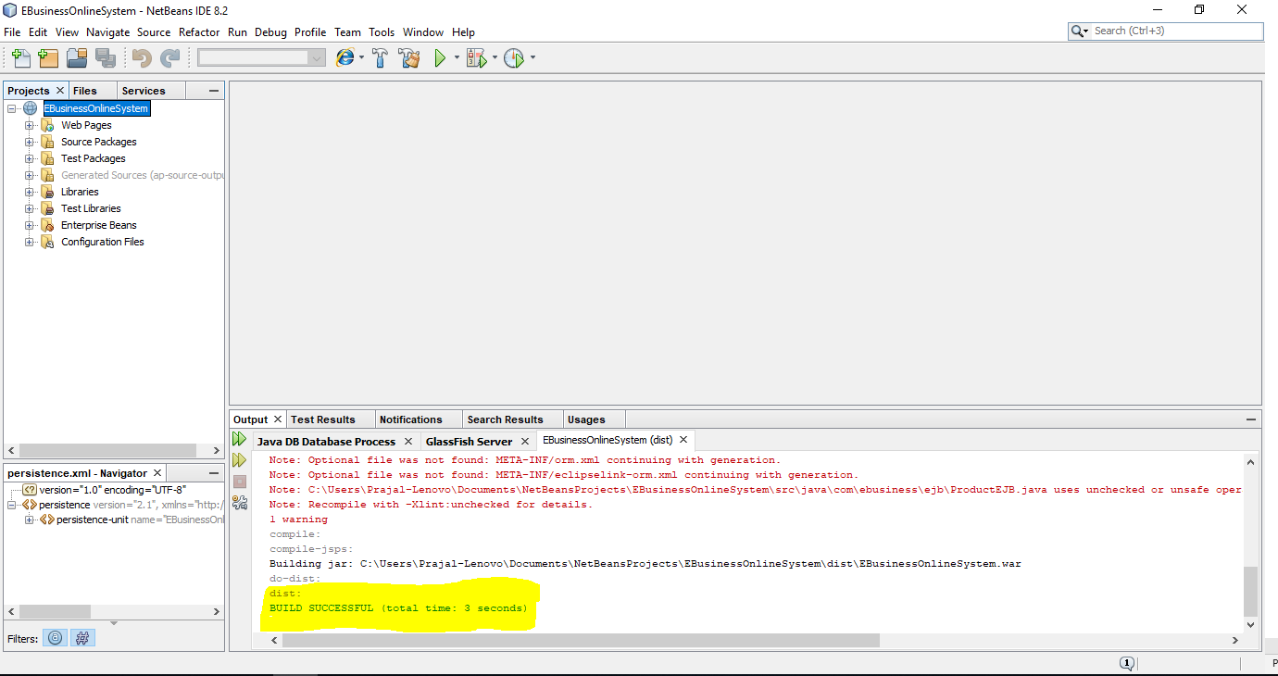

**Step 3: Making sure that this project should deploy on glassfish server only.**

Right click on project > select Properties > in Categories click on Run. By clicking on Run you will able to see below screen where you should make sure that server should be “GlassFish Server” only. If it is not then select GlassFish Server and click on Ok.

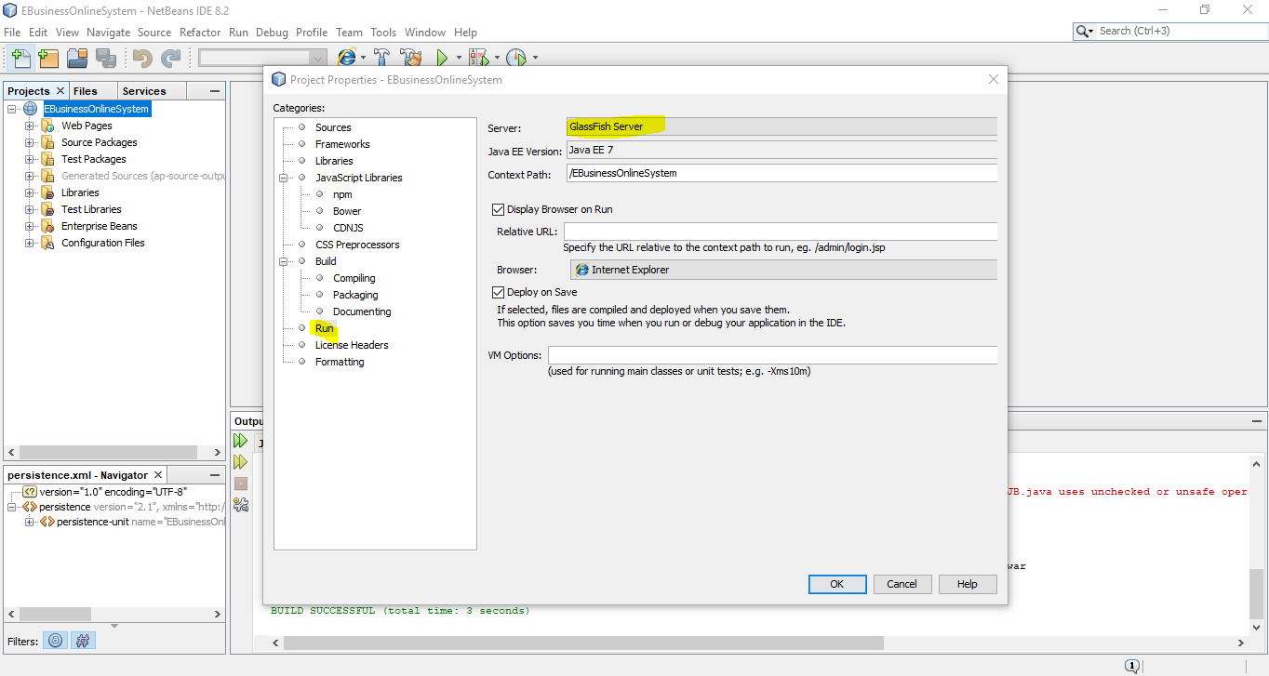

**Step 4: Deployment on Server**

Right click on project and select Deploy, it will first check the database and GlassFish server is running then directly deploy it, but not than it first start the database Derby server and GlassFish server then deploy the project.

**Step 5: Check the deployment goes successful or not.**

To check it you can see the GlassFish server log as shown in below:

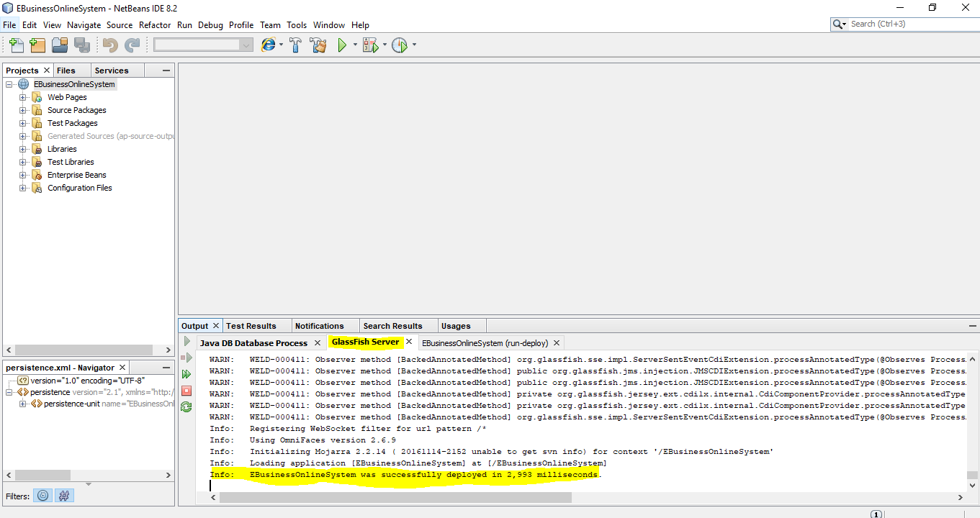

## Test Cases

|  |  |  |  |  |
| --- | --- | --- | --- | --- |
| **Test Case Id** | **Scenario** | **Test Steps** | **Test Data** | **Expected Results** |
| TU01 | Create a new Movie with valid Data | 1. Go to site <http://localhost:8080/EBusinessOnlineSystem/> 2. Click on “Create a new Movie”. 3. Enter all fields. 4. Click on “Create a movie” button. | Title=Twilight  Description=Bell Swan doesn’t expect much…  Company=Summit Ent  Platform= DVD  Classification=M  Price=14.99  Stock Number=20  Duration=125  Special Features= 1.Audio Commentary director  2. Music Video performed by Muse | User is able to see entered movie in Movie list |
| TU02 | Create a new Movie with invalid Data | 1. Go to site <http://localhost:8080/EBusinessOnlineSystem/> 2. Click on “Create a new Movie”. 3. Enter Title and Description field only. 4. Click on “Create a movie” button. | Title=God Father  Description= very famous movie… | User is able to see validation message to highlight user to enter the Company, Price, Stock number, Duration |
| TU03 | Create a new Game with valid data | 1. Go to site <http://localhost:8080/EBusinessOnlineSystem/> 2. Click on “Create a new Game”. 3. Enter all fields. 4. Click on “Create a game” button. | Title=Call of Duty-Ghosts  Description=This new chapter in the Call of Duty…  Company= Infinity Ward  Platform=PlayStation 4  Classification=M  Price=69.99  Stock Number=30  HD Video Output=1080i  Hard Drive Space=25  Number of Players=12 | User is able to see entered game in Game List |
| TU04 | Create a new Game with invalid data | 1. Go to site <http://localhost:8080/EBusinessOnlineSystem/> 2. Click on “Create a new Game” link. 3. Enter Title and Description field. 4. Click on “Create a game” button. | Title=League of Legends  Description= Most played game | User is able to see validation message to highlight user to enter the Company, Price, Stock number, Number of Players |
| TU05 | Create a new Customer with valid data | 1. Go to site <http://localhost:8080/EBusinessOnlineSystem/> 2. Click on “Create a new Customer” link. 3. Enter all fields. 4. Click on “Create a customer” button. | Name=Wei Li  Address=Bruce Highway Rockhampton  Phone Number=0749309686  Email Address= w.li@cqu.edu.au | User is able to see “Wei Li” in customer list. |
| TU06 | Create a new Customer with invalid data | 1. Go to site <http://localhost:8080/EBusinessOnlineSystem/> 2. Click on “Create a new Customer” link. 3. Enter all fields.   Click on “Create a customer” button. | Name=Prajal  Address=144 Alma Road  Phone Number=0466095230  Email Address=abc@abc | User is able to see validation message “E-mail validation failed” |
| TU07 | Create an Order with valid data | 1. Go to site <http://localhost:8080/EBusinessOnlineSystem/> 2. Click on “Create a new Order” link. 3. Select/Enter all fields. 4. Click on “Create an Order” button. | Customer=Wei Li  Item= Twilight – 14.99  Quantity=1 | User is able to see message “Successfully created the order for Wei Li” |
| TU08 | Create an Order with invalid data | 1. Go to site <http://localhost:8080/EBusinessOnlineSystem/> 2. Click on “Create a new Order” link. 3. Select/Enter all fields. 4. Click on “Create an Order” button. | Customer=Wei Li  Item=Twilight – 14.99  Quantity=0 | User is able to see validation message “Quantity: Validation Error: Specified attribute is not between the expected values of 1 and 1,000.” |
| TU09 | Check the Stock of Movies | 1. Go to site <http://localhost:8080/EBusinessOnlineSystem/> 2. Click on “The Stock of Movies” link. | N/A | User is able to see all listed stock of movies. |
| TU10 | Check the Stock of Games | 1. Go to site <http://localhost:8080/EBusinessOnlineSystem/> 2. Click on “The Stock of Games” link. | N/A | User is able to see all stock of games. |
| TU11 | Check the list of Customers | 1. Go to site <http://localhost:8080/EBusinessOnlineSystem/> 2. Click on “List of Customers” link. | N/A | User is able to see all customers that exists with the system. |
| TU12 | Search for a movie | 1. Go to site <http://localhost:8080/EBusinessOnlineSystem/> 2. Click on “Search for a Movie” link. 3. Enter Title field 4. Click on “Search for a movie” button | Title= Harry Potter | User is able to see all the details of Harry Potter movie. |
| TU12 | Search for a game | 1. Go to site <http://localhost:8080/EBusinessOnlineSystem/> 2. Click on “Search for a Game” link. 3. Enter Title field 4. Click on “Search for a game” button | Title= Call of Duty -Ghosts | User is able to see all the details of Call of Duty-Ghosts game. |
| TU13 | Search for a Customer | 1. Go to site <http://localhost:8080/EBusinessOnlineSystem/> 2. Click on “Search for a Customer” link. 3. Enter Name field 4. Click on “Search for a Customer” button | Name = Dong Li | User is able to see all the details of Dong Li customer which also include the orders made by him. |
| TU14 | Search for an Order | 1. Go to site <http://localhost:8080/EBusinessOnlineSystem/> 2. Click on “Search for an Order” link. 3. Enter Order# field   Click on “Search for an Order” button | Order# = 401 (order number may be different in your system) | User is able to see all the details of Order. |

# Coverage of the Application scenario

This application is developed using NetBeans IDE. This application is designed and developed using three tier applications. It is a web application that provide online E-Business service with two types of product named Game and Movie. Where user can add Game and Movies to sell it online. Moreover, user can also view list of Movies or Games as well as they can search individually to find more details about that particular product like available stock, company etc. Application has also included the customer and Order module through which customer can be added to the system and for those customer order can be placed for available products. Customer can also get the details about order they have made till date. There is also functionality to search a customer using name to get their details. Same way also possible to search an order through order id. User can also see the order list and customer list. Apart from this system has also drilldown option where they can get direct information about customer or movie or game without searching it individually.

# Assumptions

There are certain assumptions has been made during development of this online E-Business system:

* Customer cannot order a product more than 1000 quantity at a time.
* Product should have minimum price as 1 dollar.
* Product can have a same Title.
* Customer can have a same Name.
* While searching any records we may get multiple records as title and name can be same for two product/customer.
* For order creation, time step is default Date time step so that is different from GMT time stamp that shown in proposed system.